

BARANGAY RUNRUNO  
MUNICIPALITY OF QUEZON  
NUEVA VIZCAYA

GENERAL INFORMATION AND PROFILE

Revision: 07/30/2020

HISTORY OF RUNRUNO

- o0o -

Among the 12 Barangays that comprises the Municipality of Quezon, Barangay Runruno has been dubbed as the chosen repository of treasure of King Solomon, at least in this part of the world. While prediction still remain to be proven, Runruno nevertheless has in proven its worth in the influx socio- economic oriented ventures of people in the agri-business world.

The history of Runruno is filled with enchanting folklores and legends and the most repeated narration centers on the kind of untamed grass called “RUNO”. So vast in the area do this wild plant dominate that people referred to it as “KARUNUAN” under the leadership of Bugtong Binay-an, who was acclaimed to be the founder of this community . After it was named from that grass, the inhabitants requested to have their sitio separated from barangay Darubba and the municipality of Kasibu and be identified the name “RUNRUNO” Lorded over all suggestions. Consequently, the Municipal board of Quezon, under Resolution No. 09 of January 08, 1964 unanimously recommend and endorse to the Provincial board, the immediate clamor of the people. For no time, since the proposed creation has all prerequisites of a Barangay, the Provincial Board approved the creation through board Resolution no. 50 on January 15, 1965.

It is assumed by the people that 1950’s the first settlers to arrive in the place where the Ilongots, but later on they were driven by the arrival of the Igorot tribes. Pocket mining started in 1962 and arrival of mining explorers started in 1970’s. Calderon Company was the first mining corporation. Later on logging operation had started in which sinapal sawmill in Solano operationalized. This activity become rampant in the place wherein most of the people get their source of income and eventually road networks going to the area were opened. On the other hand, public market was constructed under Mayor Pacis administration. In the year 2005 up to the present the FCF Minerals Inc. came for exploration.

In the early 1980’s typhoon Kading and Aning resulted to flashfloods causing the death of one person and farm animals as well as the destruction of the belongings and properties of residents. In mid of 1990 there was strong intensity of earthquake. Similarly in 2006, that was October 30 night which devastated the same and there are 11 dead in typhoon Paeng. From time to time, infrastructure developments were made such as the establishments of Primary and Elementary School and the Runruno National High School (2007), electrification of Runruno proper, and some other Sitios, barangay Assembly Hall, SK office, multi-purpose drying pavements, Daycare centers, spring development and other infra-related accomplishments.

MAP OF BARANGAY RUNRUNO

- o0o -

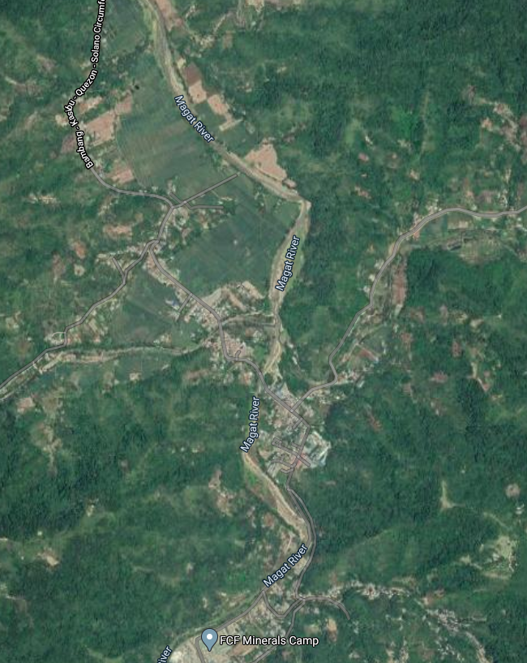

BARANGAY RUNRUNO is composed of 7 Sitios headed by one Councilman or Kagawad assigned per Sitio in this Barangay. But as days passed by up to the present due to increasing member of population, barangay was divided into twelve (12) Sitios namely:

* Atan
* Bit-ang
* Busat
* Cabinauangan
* Centro
* Compound
* Dipilipig
* Dumaliguia
* Kinalabasa
* Lintungan
* Marangad
* Tayab

At the periods when Barangay Runruno was created, the Barangay was governed by a “**Teniente del barrio**”. The basis of choosing its leader before was done by means of “VIVA VOCE” meaning to say by word of mouth. It was only in 1966, when there was a Barangay Election and this election was done through secret balloting. Since then the head of the Barangay is the **Barangay Captain** and no longer “Teniente del barrio”. Indicated herein are the succession of the **Barangay Officials** and the length of service rendered in the Barangay.

BARANGAY COUNCILS & STAFFS

- o0o -

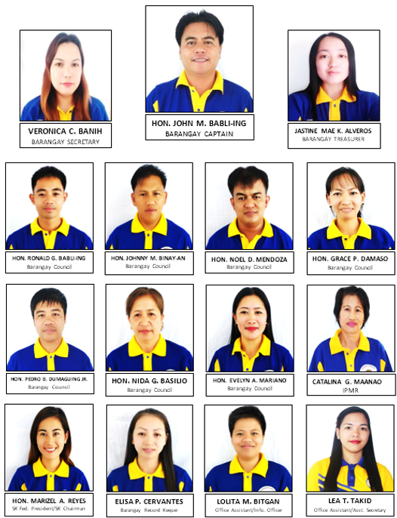

BARANGAY COUNCILS & STAFFS

- o0o -

HON. JOHN M. BABLI-ING ------------------------- Brgy. Captain

HON. RONALD G. BABLI-ING ------------------------- Brgy. Kagawad

HON. JOHNNY M. BINAY-AN ------------------------- Brgy. Kagawad

HON. NOEL D. MENDOZA ------------------------- Brgy. Kagawad

HON. GRACE P. DAMASO ------------------------- Brgy. Kagawad

HON. PEDRO B. DUMAGUING JR ------------------------- Brgy. Kagawad

HON. NIDA G. BASILIO ------------------------- Brgy. Kagawad

HON. EVELYN A. MARIANO ------------------------- Brgy. Kagawad

HON. MARIZEL A. REYES ------------------------- SK Chairman

HON. CATALINA G. MAANAO ------------------------- IPMR

VERONICA C. BANIH ------------------------- Barangay Secretary

JASTINE MAE K. ALVEROS ------------------------- Barangay Treasurer

ELISA P. CERVANTES ------------------------- Barangay Book Keeper

LOLITA M. BITGAN ------------------------- Barangay Office Assistant

LEA T. TAKID ------------------------- Assistant Secretary

RUNRUNO BARANGAY HALL

- o0o -

